**07 – Tuple/Set**

**Ex. No. : 7.1 Date: 16.05.24**

**Register No.: 231401075** **Name: Poojasree.k**

# Binary String

Coders here is a simple task for you, Given string str. Your task is to check whether it is a binary string or not by using python set.

Examples:

Input: str = "01010101010"

Output: Yes

Input: str = "REC101"

Output: No

**For example:**

|  |  |
| --- | --- |
| **Input** | **Result** |
| 01010101010 | Yes |
| 010101 10101 | No |

**Program:**

a = input() try:

c = int(a) print("Yes") except:

print("No")

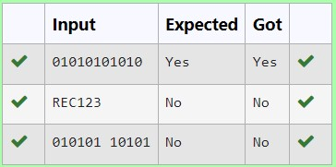

**Ex. No. : 7.2 Date: 16.05.24**

**Register No.: 231401075** **Name: Poojasree.k**

# DNA Sequence

The **DNA sequence** is composed of a series of nucleotides abbreviated as 'A', 'C', 'G', and 'T'.

For example, "ACGAATTCCG" is a **DNA sequence**.

When studying **DNA**, it is useful to identify repeated sequences within the DNA.

Given a string s that represents a **DNA sequence**, return all the **10-letterlong** sequences (substrings) that occur more than once in a DNA molecule. You may return the answer in **any order**.

**Example 1:**

**Input:** s = "AAAAACCCCCAAAAACCCCCCAAAAAGGGTTT" **Output:** ["AAAAACCCCC","CCCCCAAAAA"] **Example 2:**

**Input:** s = "AAAAAAAAAAAAA"

**Output:** ["AAAAAAAAAA"]

**For example:**

|  |  |
| --- | --- |
| **Input** | **Result** |
| AAAAACCCCCAAAAACCCCCCAAAAAGGGTTT | AAAAACCCCC  CCCCCAAAAA |

**Program:** def findRepeatedSequences(s):

sequences = {}

result = []

for i in range(len(s) - 9):

seq = s[i:i+10]

sequences[seq] = sequences.get(seq, 0) + 1 if sequences[seq] == 2: result.append(seq)

return result s1 = input()

for i in findRepeatedSequences(s1):

print(i)

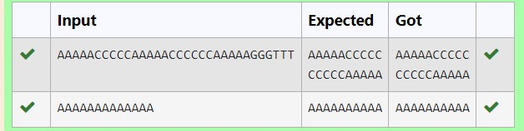

**Ex. No. : 7.3 Date: 16.05.24**

**Register No.: 231401075** **Name: Poojasree.k**

# American keyboard

Given an array of strings words, return *the words that can be typed using letters of the alphabet on only one row of American keyboard like the image below*.

In the **American keyboard**:

* the first row consists of the characters "qwertyuiop",
* the second row consists of the characters "asdfghjkl", and ● the third row consists of the characters "zxcvbnm".
* 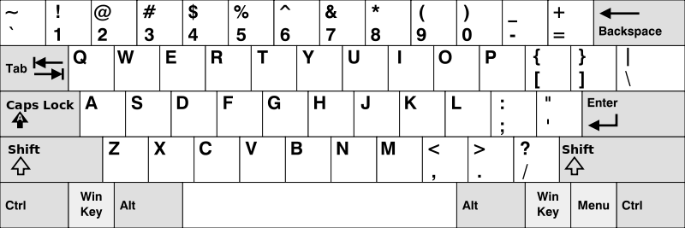

●

* **Example 1:**
* **Input:** words = ["Hello","Alaska","Dad","Peace"] ● **Output:** ["Alaska","Dad"] ● **Example 2:**
* **Input:** words = ["omk"] ● **Output:** []
* **Example 3:**
* **Input:** words = ["adsdf","sfd"]
* **Output:** ["adsdf","sfd"]

●

* **For example:**

|  |  |
| --- | --- |
| **Input** | **Result** |
| 4  Hello  Alaska  Dad  Peace | Alaska Dad |

**Program:**

def findWords(words): row1 = set('qwertyuiop') row2 = set('asdfghjkl') row3 = set('zxcvbnm')

result = [] for word in words:

w = set(word.lower())

if w.issubset(row1) or w.issubset(row2) or w.issubset(row3):

result.append(word) if len(result) == 0: print("No words")

else:

for i in result: print(i)

a = int(input()) arr = [input() for i in range(a)] findWords(arr)

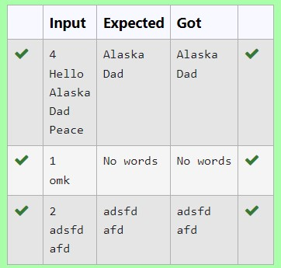

**Ex. No. : 7.4 Date: 16.05.24**

**Register No.: 231401075** **Name: Poojasree.k**

# Print repeated no

Given an array of integers nums containing n + 1 integers where each integer is in the range [1, n] inclusive.There is only **one repeated number** in nums, return *this repeated number*. Solve the problem using [set.](http://118.185.187.137/moodle/mod/resource/view.php?id=734)

**Example 1:**

**Input:** nums = [1,3,4,2,2]

**Output:** 2

**Example 2:**

**Input:** nums = [3,1,3,4,2]

**Output:** 3

**For example:**

|  |  |
| --- | --- |
| **Input** | **Result** |
| 1 3 4 4 2 | 4 |

**Program:**

n =input().split(" ") n = list(n)

for i in range(len(n)):

for j in range(i+1,len(n)): if n[i] == n[j]: print(n[i])

exit(0)

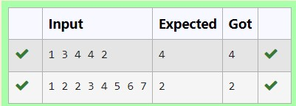

**Ex. No. : 7.5 Date: 16.05.24**

**Register No.: 231401075** **Name: Poojasree.k**

# Check Pair

Given a tuple and a positive integer k, the task is to find the count of distinct pairs in the tuple whose sum is equal to **K**.

**Examples:**

**Input**: t = (5, 6, 5, 7, 7, 8 ), K = 13

**Output**: 2

Explanation:

Pairs with sum K( = 13) are {(5, 8), (6, 7), (6, 7)}.

Therefore, distinct pairs with sum K( = 13) are { (5, 8), (6, 7) }. Therefore, the required output is 2.

**For example:**

|  |  |
| --- | --- |
| Input | Result |
| 1,2,1,2,5  3 | 1 |
| 1,2  0 | 0 |

**Program:** def count_distinct_pairs(t, K):

distinct_pairs = set() for i in range(len(t)):

for j in range(i + 1, len(t)): if t[i] + t[j] == K: distinct_pairs.add((min(t[i], t[j]), max(t[i], t[j])))

return len(distinct_pairs)

t_input = input()

t =tuple(map(int,t_input.split(',')))

K = int(input()) print(count_distinct_pairs(t, K))

